**ReXgen API idea**

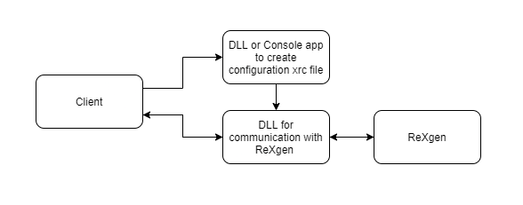

1. Rework the current dll to work in similar way to the Kvaser dll (where applicable).

Functionality:

- Send Configuration

- Get Configuration

- Get List of Channels (Can, Accelerometer, Gyro etc.)

- Send / receive message.

- Live data.

- Reflash.

- SD card content.

- Download file.

1. Currently the code that creates the configuration (xrc) file is written in C# and it can only be used by .net applications. It cannot be used as a typical dll. There are 2 solutions to this problem – to rewrite the code on C++ and create a dll or to use the current code as a console application.

Functionality:

* Create xrc file from xml file.
* Create mf4 file from rxd file.
* Possible Future functionality can be creating configuration using commands like AddAccelerometer, AddGyro etc.

The proposed solution will work only under Windows, so if the idea is multiplatform solution a different approach would be needed.



**RgUSBdrv.dll API Commands**

**unsigned char DeviceIsReady ()#**

Returns 0 if the device is connected.

**unsigned char GetFirmwareVersion(char* version)#**

Gets the logger firmware version

**unsigned char SendConfiguration( char* FileName, short* Status)#**

returns 0 if successfully sent.

If the function returns 0 check Status.

Status 0 – Configuration OK

Status 1 – Bad Config

**unsigned char ReflashLogger(char* FileName, short* Status)#**

returns 0 if file successfully sent.

If the function returns 0 check Status.

Status 0 – Reflash OK

**unsigned char FormatSDCard(unsigned short FormatType, short* Status)**

returns 1 if there is a problem with usb communication.

If the function returns 0 check Status.

Status 0 –Format OK

**unsigned char FormatSDCardPartitions(unsigned short FormatType, unsigned char NumOfPartition, unsigned char* PartitionPercent, unsigned short* Status)**

**Parameters:**

NumOfPartition – Split the SD card to a number of partitions for downsampling logging. Max partitions 4.

PartitionPercent – percentage for each partition.

**Function Output**

returns 1 if there is a problem with usb communication.

If the function returns 0 check Status.

Status 0 –Format OK

**unsigned char InitLiveData (unsigned char Channel)#**

initialize live data mode

**unsigned char GetLiveData(unsigned char Channel, unsigned char* LiveData)**

start receiving live data

**unsigned char StopLiveData(unsigned char Channel)#**

stop sending live data

**unsigned int GetDateTime()#**

Date time is in UNIX Date time format

**unsigned char SetDateTime(int DateTimeUNIX)#**

Set logger date time. Date Time is in UNIX format

**unsigned short GetLogCount()#**

returns the number of Log Files in the SD Card

**unsigned short GetPartitionLogCount(unsigned char partition)#**

returns the number of Log Files in a specific partition of the SD Card

**unsigned char GetSDLogInfo(unsigned short LogNumber, unsigned int* StartLogDateTime,**

**unsigned int* EndLogDateTime, unsigned int* LoggingTimeStart,**

**unsigned int* LoggingTimeEnd, unsigned int* LogStartDataSector,**

**unsigned int* LogEndDataSector, unsigned int* LogDataSize,**

**unsigned char* GUID, unsigned char* FileName)**

Get information for a specific log file. The input parameter is the LogNumber.

**unsigned char GetPartitionLogInfo(unsigned char partition, unsigned short LogNumber,**

**unsigned int* StartLogDateTime, unsigned int* EndLogDateTime,**

**unsigned int* LoggingTimeStart, unsigned int* LoggingTimeEnd,**

**unsigned int* LogStartDataSector, unsigned int* LogEndDataSector,**

**unsigned int* LogDataSize, unsigned char* GUID, unsigned char* FileName)**

Get information for a specific log file of a specific partition. The input parameters are the Partition number and the LogNumber.

**RxLibrary.dll functions**

**bool XmlToRxc(string xmlFileName, string rxcFileName)**

Converts XML to Configuration file (RXC)

**bool ConvertData(string inputpath, string outputpath)**

converts RXD to MF4, ASC, BLF, MAT, CSV

**string LastConvertStatus()**

Returns the last convert status

The dll is a .Net Standard 2.0 dll and works under Linux too.